Student Name: Weight: 10%
Student ID: Marks: /24

Lab: Creating an Interactive Webpage
In this lab, you’ll demonstrate your ability to use more advanced HTML elements to create a webpage with interactive components. This lab may be completed during a provided work period or outside of scheduled class time, as indicated by your instructor.

Instructions
- Working individually, create an HTML webpage with a linked CSS file that contains all elements listed in the Site Contents section below.
- Upload the following to Brightspace:
  - Your github pages site
  - A github repo link that demonstrates:
- An index.html file, linked to your CSS file
- A contact.html file, linked to the same CSS file
- A styles folder containing your styles.css file
- An images folder containing any required logos or pictures
- An empty scripts folder
  - A screenshot showing successful validation of your HTML from https://validator.w3.org/
  - A screenshot showing your document outline from https://hoyois.github.io/html5outliner/
  - A screenshot showing successful validation of your CSS from http://jigsaw.w3.org/css-validator/
- Submit your lab by the due date listed in Brightspace. See the marking criteria below for details on how you will be assessed.

Site Contents
Create a fictious online store containing two pages:
- A home page
- A contact page
Both pages will have the same header and footer.
The header will contain:
- The name of the store
- A logo
- A navigation section containing links to the home page and to the contact page
The footer will contain:
- Your name
- Moot links to social media pages (i.e., using an href value of #)
The home page will include:
- At least two sections
Note: Use placeholder text for each section
The contact page will contain:
- A form with at least three elements
- A Submit button
The layout of your page should look similar to these mock-ups.
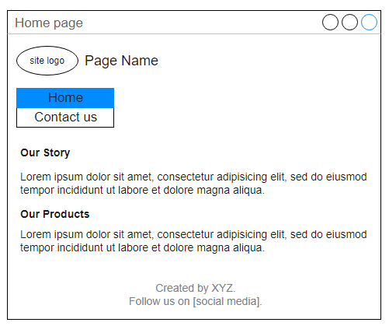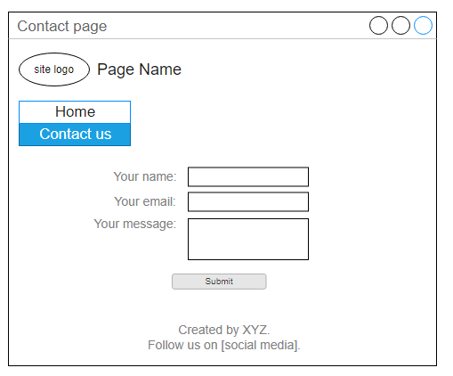
© 2022, Southern Alberta Institute of Technology

Marking Criteria
 | 0 Marks | 1 Mark | 2 Marks | Marks
HTML Syntax | No HTML is submitted. | Code is visible on the page. | Page renders without visible errors. | /2
HTML Syntax | No HTML is submitted. | HTML has syntax errors. | HTML passes validation with no errors. | /2
Page Content | Headers and footers missing. | Headers and footers partially implemented. | Headers and footers fully implemented. | /2
Page Content | Home page content missing. | Home page content partially implemented. | Home page content fully implemented. | /2
Page Content | Contact page content missing. | Contact page content partially implemented. | Contact page content fully implemented. | /2
Accessibility | No images are included. | One or more images are missing alt-text. | All images have descriptive alt-text. | /2
Links | Anchors were not included. | Anchors do not work. | Anchors correctly link to each page. | /2
HTML Form | Form elements were not included. | Insufficient form elements or attributes have been used. | Appropriate form elements and attributes have been used. | /2
CSS Syntax and Formatting | No CSS is submitted. | CSS stylesheet is not correctly linked or multiple stylesheets were created. | A single CSS file is correctly linked to both web pages. | /2
CSS Syntax and Formatting | No CSS is submitted. | CSS has one or more errors in validation. | CSS passes validation with no errors. | /2
CSS Syntax and Formatting | No CSS is submitted. | CSS contains inconsistent indentation, unnecessary blank lines, incorrect selectors or significant repetition within declarations. | CSS is well formatted, with minimal repetition. Appropriate and simple selectors have been used. | /2
HTML Attributes | No HTML is submitted. | Obsolete HTML elements are included. | Appropriate HTML elements are used in page. | /2
Total |  |  |  | /24

